eBirdSoft Project Presentation

What is eBirdSoft?

eBirdsoft is a project coded in Python (version 2.7, with Tkinter) providing a real-time GUI interface in order to test seismic equipment such as eBird body and wings technology.

It is designed to work onto various platforms such as Linux RedHat for backward compatibility with the BOCS system but will work on most platforms including Mac OS and windows (tested proficiently on Linux and windows).

eBirdSoft is using multithreaded/multiprocessing applications to utilise the full potential of Konsberg Seatex ECLT commands. It will perform background tasks and regroup results in a concise manner.
The results are displayed into tables to simplify the way the equipment functions are represented

This application comes with powerful graphic tools to analyse equipment behaviours but also to store data in a local SQLITE database. Plots and graph can be generated to more easily understand the overall mechanisms such as current charging, voltage variations, eBird body current leakage etc.

Below are snapshots of eBirdSoft graphic interfaces

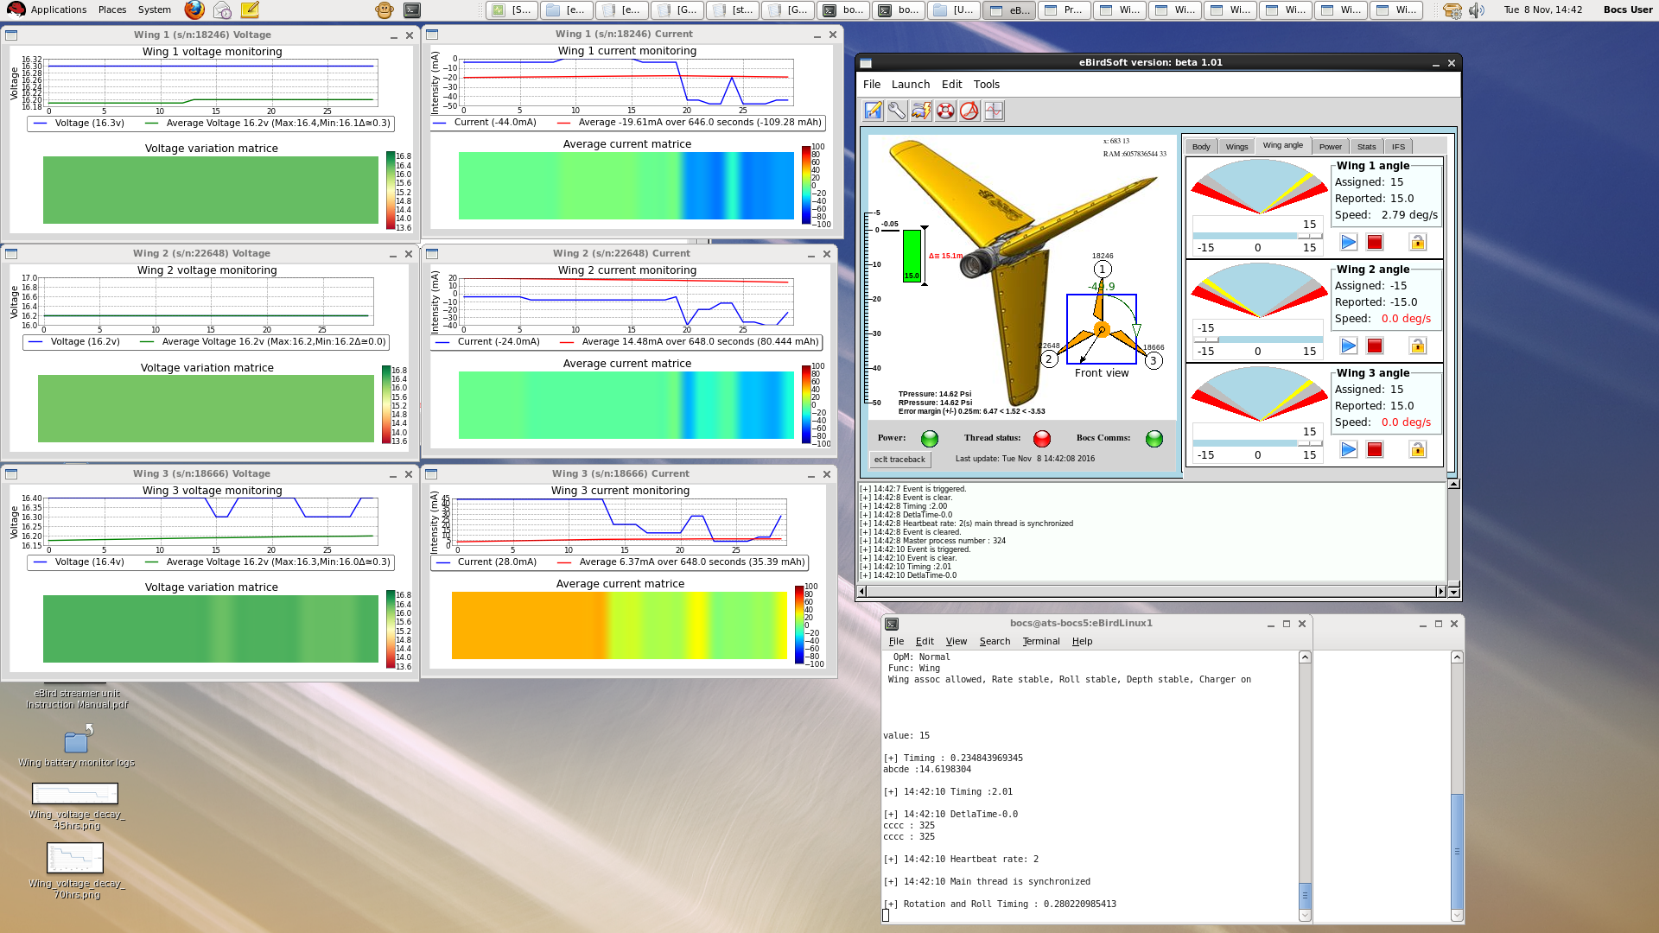

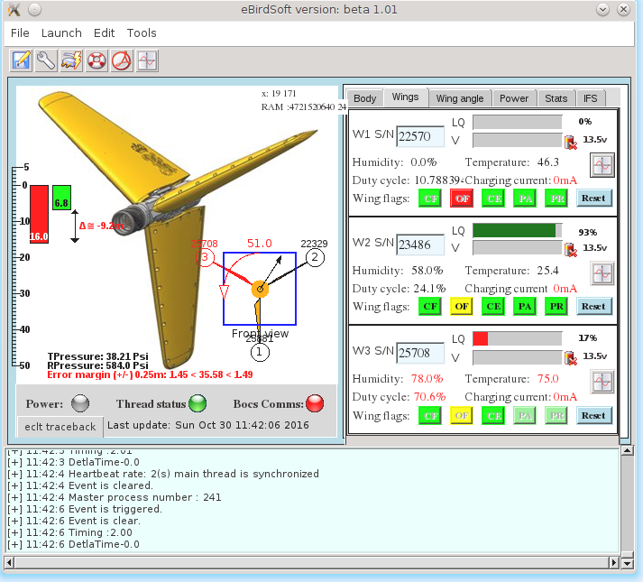

Actual version of eBirdSoft and future improvements:

A final version will eventually arrive in the first quarter of 2017, compiled into an RPM package

New features/improvements could be added to a future version for example:
- IFS reporting - Historical repair order for a specific equipment,or failure rate statistics.
Auto creation of repair order with related issues and performance monitoring.
- PDF reporting system, - Certifying that the equipment complies with PGS standards (benchmark tests).
- Real-time - Online analysis tools to clearly identify issues on streamers using matrix colour coded information.
- Offline database analysis - To extract pool statistics and graphically represent issues on certain types of equipment.

What can eBirdSoft provide in addition to BOCS ?:

It provides a testing platform with a very concise and intuitive way to monitor and test eBird equipment via graphical tools
It is ideal for intermittent issues as eBirdSoft is capable of continuously monitoring eBird body functions
It offers the possibility to implement IFS applications to generate fault reports.
It uses online real-time graphical tools to monitor critical conditions ( rotation matrix, force matrix etc)

Collaboration or contributions?:

If anybody is interested to contributing or has any questions regarding the project, please contact me at the following address:

yoyoberenguer@gmail.com

Yoann Berenguer

Observer ATS

